Write an algorithm that exchanges the value of two variables: x and y. The output must be: the value of variable of y will become the value of variable x, and vice versa.
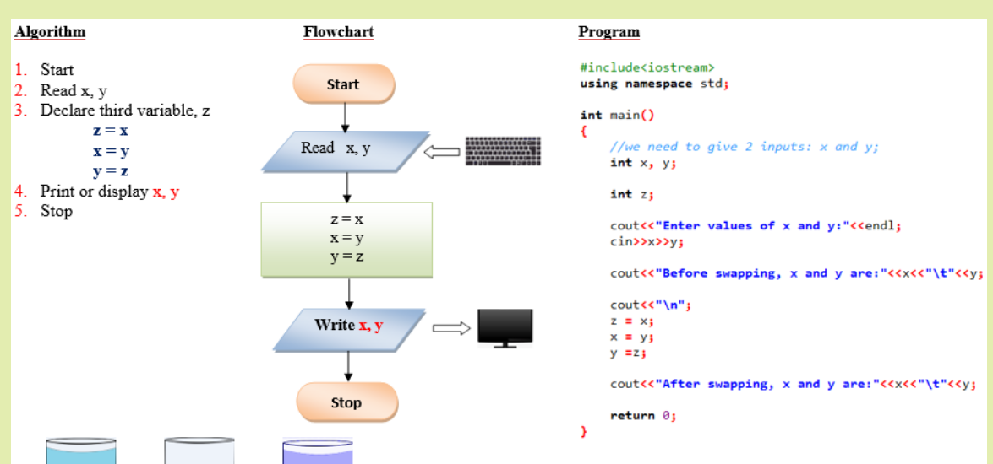
Draw a flowchart that converts the input dollar to its peso exchange rate equivalent. Assume that the present exchange rate is 58.50 pesos against the dollar. Then display the peso equivalent exchange rate.
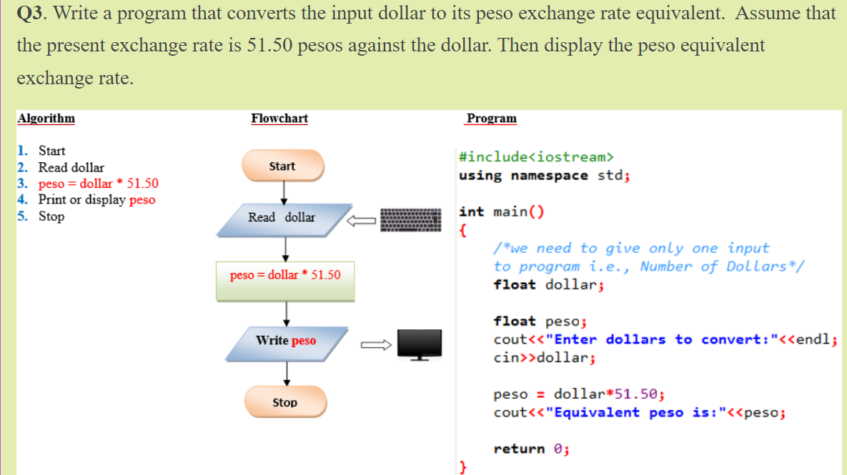
Write an algorithm and draw a flowchart that converts an input inch(es) into its equivalent centimeters. Take note that one inch is equivalent to 2.54cms.
